2019-2021
CONNECT PROJECT
LESSON PLAN

INDEX
PART A.MY LESSON PLAN
1.Sytatic andDynamicCharacteristics
1.1.Title of theLesson
1.2.Teaching Siuation
1.2.1.Purpose of Teachingand Learning
1.2.2.Curricular Spefications
1.2.3.Coursebook Spefications
1.3.Learners’ Profile
1.3.1.Number of Learners in Class
1.3.2.Age(s)
1.3.3.Mother Tongue(s)
1.3.4.Nationality(ies)
1.3.5.Level of Proficiency
1.3.6.Other LanguagesTheyUse
1.3.7.Learners’ CurrentUse of English
1.3.8.Learners’ Language Needs
1.3.9.Learners’ BeliefsandAttitudes
1.4.Materials andResourcesUsed
1.5.Class Geography
1.6.Overall Purpose
1.7.Specific Objective(s) of theLesson
1.8.Assessment and/orCorrectionPolicy
1.9.Teacher andLearnerRoles
1.10.Anticipated ProblemsandWaystoOvercomeThem
2.Structure,DescriptionandTiming of theTasks/Activities
PART B.EVALUATION OF THE LESSON

PART A.MY LESSON PLAN

1. Static & dynamic characteristics

1.1.Title of the lesson: Chrysanthemum

Chrysanthemumis the story of a mouse who loves her name.She loves the wayit sounded and she loves the way it looks.She thinks her name is perfect until she goes to school.At school her classmates make fun of her name because it’s so long and because it comes after a flower.Chrysanthemum has to learn how to answer to bullies.

1.2.Teaching situation

1.2.1.Purpose of teaching and learning:

Thefocus in thislesson is morphologically on teaching ‘Simple Past Tense’ , phonologically on ‘complexclusters’, lexicologically on ‘botany’ to 5th graders, socially on raisingawarenesstodifferences.

1.2.2.Curricular specifications:

In Turkish Public Schools the students have 3 hours of language classes a week.The Ministry of Turkish Education has a clearly designed foreign language teaching curriculum and objectives.They send books in each and every part of Turkey at the beginning of each school year.

The aim for the public secondary schools is to graduate the students at upper-intermediate level at foreign languages.

The books have lots of grammar activities,fewerlistening,reading and writing activities.The teaching of mostly material and relatively social culture is done in the State’s Books,but the teaching of subjective culture remains to the teachers’ backgrounds and personal developments.

Some public schools(like mine) have English Preparatory Classes at 5thGrade.In these schools the language teaching hours can be raised up to 13.In TEB Ataşehir School which I am teaching,the 5th graders have 13 hours English a week.The teachers can use exra-curricular materials like the listening activities in Chrysanthemum.

Chrysanthemum is one of the favourite listening text of my students.We usually listen,read and speak about the story towards the end of the first semester,after the students learn talking about past activities.

In this lesson plan,the objective to undersand,read,write and speak about past activities is in the curriculum.The students also experience third person narrative with some dialogue,names of the characters like names of flowers,Simple,compound and complex sentences and the vocabulary ;winsome,scarcely,carnation,chrysanthemum,Parcheesi,wilted,indescribable.
1.2.3.Coursebook specifications:

The curriculum focuses on learners to be able to read,listen,write and speak intermediate or upper-intermediate levels when they graduate from the secondary public schools.

1.3.Learners’ profile

1.3.1.No of learners in class: 39

1.3.2.Age(s): 10-11 years old

1.3.3.Mother tongue(s): Turkish

1.3.4.Nationality(-ies): Turkish

1.3.5.Level of proficiency in English:Pre-Intermediate

1.3.6.Other languages they use: English

1.3.7.Learners’ current use of English: Thestudentsarefrom a publicsecondaryschool on theAsianpart of İstanbul.Ataşehir is a relativelynewlylocatedarea,became an importantresidenceafterthe 1999 earthquake.Thestudentsarefrommiddle SES orupper SES families.Theyareboth EFL and ELF learners.Theyuse English not only as a foreignlanguagetaught at school,butalsouse it as an extramuralEnglish,i.ethey listen tosongs,watchfilms,playcomputergames,havevacations on abroadandthereareongoingErasmusprojectssotheyhavefriendsfromEurope.Themedium of communication is English in allthese.

1.3.7.Learners’ language needs: The learners mostly experience pedagocicaltasks,the teachers see them as ‘social agents’ so the school system prefers having communicative,real life and pedagocical tasks.

1.3.8.Learners’ beliefs and attitudes: English is the global language.Peoplefromdifferentparts ,differenteducationalbackgrounds,differentages,different SES use it tocommunicate.Mystudentsusuallyneed it to be engaged in popular culture,i.etoplaycomputergames,towatchfilms,writeandread on internet.
Thestudents in theschoolareaware of thesocialandgeographicalvariations of English,but I thinktheyalsohavesomesteretypicalprejudicesagainstit,i.emost of themhavepositivediscriminationtonativeAmericanand English speakers.

1.4.Materials and resources to be used in the lesson: Smart Board,Worksheets,Internet,Sticky Posters

1.5.Class geography: Seating

1.6.Overall purpose(s) of the lesson:Raise their awareness on different lives and bullying at school,develop listening and speaking skills.

1.7.Specific objective(s) of the lesson:Developsubskills of listening.

1.8.Assessment and/or correction policy:Selfcorrection,Peer correction after the task completed.

1.9.Teacher and learner roles:Teacher is the facilitator.

1.10.Anticipated problems and ways to overcome them:The Students may not understand the text properly because of the new vocabulary so the teacher work out the new words before listening(Activity 1).
The Students may not feel comfortable while working in groups(Activity 5).The teacher help them to use their mother tongue if they have in a real difficulty.

2) Structure, description and timing of the tasks/activities

Lesson Plan
Chrysanthemum
 | Procedure | Objectives | Interaction  * | Time  **
Phase 1  (Pre-listening) | Step 1:  The teacher brings cards which have flowers on it,elicits the SS to name them in English.  (Expected answers;Daisy, Rose,Iris,Orchid,Tulip ,Sunflower)  (If they have difficulty in naming finding English equivalents,the class can talk about their names in their mother tongue-translanguaging) | To motivate | Teacher-Student/  Student/Student | 5 min
 | Step 2: Now,the teacher takes the picture of chrysanthemum and asks if they know its Turkish name(It’s Kasımpatı).  She also explains they are going to watch a story about a girl whose name is Chrysanthemum.  Then she lets the class listen and watch the beginning of the story.(0:00-0:47 min).  After listening the first part,she asks if they know anybody who has his/her name after a flower.  (Expected answers;Rose,Daisy, Iris in English,Gül,Kardelen ,Manolya in Turkish).  The teacher writes the answers on board.If there is no answer,she gives Turkish examples; Gül(Rose) or Kardelen(Snowdrop). | To integrate to the story | Student-centered | 3min
Phase 2  While-listening) | Step 3: The class listens and watches the story.At several points the teacher pauses and asks questions;  1. What does Chrysanthemum love about her name?(0:48-2:09 min)  (Expected answer : she loves the spelling of her name)  2.What makes Chrysanthemum change about her name?(2:09-2:40 min)  (Expected answer:Her classmates reactions to her name).  3.What do the children at school say about Chrysanthemum’s name?(2:40-3:55 min)  (Expected answer:They say that it is a flower name,She has to be in forests with other dirty things andthey also say that it’s too long)  4.How do Chrysanthemum’s mother and father try to make her feel better about when she comes home from school?(3:55-5:16 min)  (Expected answer:They prepare her favourite dinner and desert,they read her favourite story and poem) | To comprehend the story | Teacher-centered | 10 min.
 | Step 4: The T plays the last part.There is a pregnant music teacher,the students admire at her,her name is Carnation and planning to give her daughter the name Chrysanthemum.  The T.asks  5.What was Chrysanthemum’s dream?  (Expected answer:She dreamt her name as Rita)  6.What was Chrysanthemum’s nightmare?  (Expected answer: That night Chrysanthemum dreamed that she really was a chrysanthemum. She sprouted leaves and petals. Victoria picked her and plucked the leaves and petals one by one until there was nothing left but a scrawny stem. )  7.How did her feelings change after she met Mrs.Twinkle,the music teacher.?  (Expected answer:She started to love her name again) | To raise the awareness to differences and to accept differences as a gift | Teacher-Student  Student/Student | 5 min.
Phase 1  (Post-listening) | Step 5: Activity 3.The teacher wants students to work in pairs,gives them worksheets on which the question is;How many words can you make from the letters in Chrysanthemum?  (Expected answers:merchant ,ancestry,surname, summary, rhythm, nature, anthem…..etc)  Activity 4.The teacher wants students to find words from their names.  How many words can you make from the letters in your name?  (Ecpectedanswers:My name is Müjgan.Turkish nouns an(at that moment),gam(sorrow), gün(day) can be derived.) | To enjoy studying on English  To be aware of the different sounds among different languages | Student-Student  Student-Student | 5 min  5 min.
 | Step 6: The teacher wants students to work in groups and asks ‘Can you write the foreign names you know?’ Now,choose a country,i.eUSA,England,Germany…etc and a name,i.eHans,Rita …etc and imagine you come from in this class as a guest student.How do your classmates behave you?How can you communicate with them?  Work in groups,one is a guest student,the others welcome and communicate with her/him.The volunteers can act it out.  End of the lesson.  The teacher says ‘I hope you have enjoyed the story.Now as homework,think about our last activity.Imagine and write a story about a different life from yours.Please be ready to share it with your classmates.Have a nice day! | To raise awareness,to test the students’ stereotypes, to experience of being a foreigner and to experience ELF. | Student-student  (Group work) | 7 min.
Tasks/Activities included in the lesson

Activity 1.Flowers in English(Teacher-students interaction)

Activity 2.While Listening.Wh-Questions asked by teacher to understand the plot. Listening:https://youtu.be/7fkR7X4SevE

Activity 3.How many words can you make from the letters Chrysanthemum(pair-work)

Activity 4..How many words can you make from the letters of your name.?

Activity 5.Write as many foreign names as you can.Now,Choose a country,pretend to be a guest student from this country.Choose a name from the list .Work in groups ,try to communicate with the guest students from other countries.How do you describe the experience?(Group work)

Activity 6.Homework.Think about the lastactivity.Imagine and write a story about a different life from yours.Please be ready to share it with your classmates.
ACTIVITIES

ACTIVITY –TYPES OF FLOWERS(PRE-LISTENING)

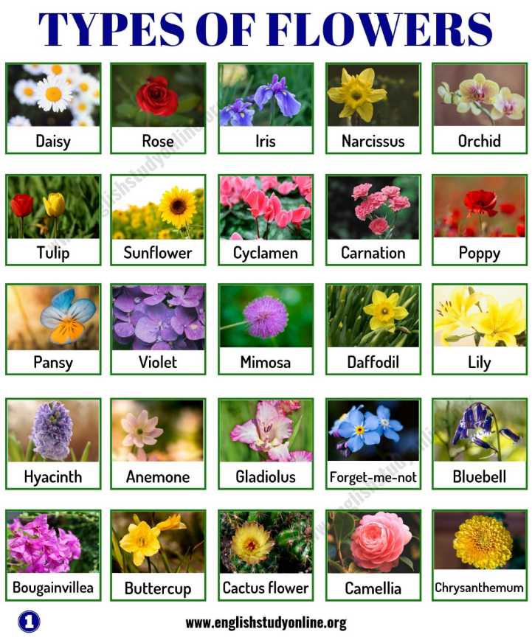

ACTIVITY 2-WH QUESTIONS( WHILE LISTENING)

1. What does Chrysanthemum love about her name?(0:48-2:09 min)
(Expected answer : she loves the spelling of her name)
2.What makes Chrysanthemum change about her name?(2:09-2:40 min)
(Expected answer:Her classmates reactions to her name).
3.What do the children at school say about Chrysanthemum’s name?(2:40-3:55 min)
(Expected answer:They say that it is a flower name,She has to be in forests with other dirty things and they also say that it’s too long)
4.How do Chrysanthemum’s mother and father try to make her feel better about when she comes home from school?(3:55-5:16 min)
(Expected answer:They prepare her favourite dinner and desert,they read her favourite story and poem)

5.What was Chrysanthemum’s dream?
(Expected answer:She dreamt her name as Rita)
6.What was Chrysanthemum’s nightmare?
(Expected answer:
7.How did her feelings change after she met Mrs.Twinkle,the music teacher.?
(Expected answer:She started to love her name again)

ACTIVITY 3(POST-LISTENING)

Worksheet 2(Pair-work)
WORK IN PAIRS.
How manywords can you words can you make from the letters in Chrysanthemum?
1.
2.
3.
4.
5.

ACTIVITY 4(POST-LISTENING)
How manywords can youmakefromtheletters in your name?
My name is …………………………………
1.
2.
3.
4.
5.

ACTIVITY 5(GROUP WORK)

Write as many foreign names as you can.Now,Choose a country,pretend to be a guest student from this country.Choose a name from the list .Work in groups ,try to communicate with the guest students from other countries.How do you describe the experience?(Group work)

I am from……………………………
My name is ………………………

6.ACTIVITY 6(HOMEWORK)

Think about the lastactivity.Imagine and write a story about a different life from yours.Please be ready to share it with your classmates.

PART B.EVALUATION OF THE LESSON

I carried out the listening lesson ‘ Chrysanthemum’ with the 5th graders on July 10,2020 at 2 pm on ZOOM.There were 30 students on ZOOM,all willing to have a listening Session together as we have been away from each other for about 4 months because of Covid19.
The Pre-Listening Activity(Types of Flowers) was done perfectly.I am surprised as they know more names than I expected.They liked the little girl in the story and I heard them trying to pronounce ‘Chrysanthemum’ .They are also very good at giving examples from the Turkish names which came after flowers like Gül,Çınar,Papatya,Kiraz,Lale.One of my student also added she liked the way her name sounded.Her name is Defne.The others also wanted to hear their names.I said all of them.
During the while Listening Activity,most students had difficulty in understanding the story in detail.Ihad to talk about the new words winsome,scarcely,carnation,Parcheesi,wilted,indescribable.I formed sentences and also wrote these words on board,waited for them to note down them on their notebooks.
They tried to answer WH-Question but again they needed my help in some points.They usually gave me lexically correct but morphologicaly wrong answers,i.e She dream/She grow-they forgot to use simple past forms while talking about past.I didn’t correct them while speaking.After while listening,I let the volunteers wrote the answers on the board so they had a chance to correct themselves.
The post-listening activities were the most enjoyable ones.We had real fun while making words from both Chrysanthemumand our names.They were very eager to share the Turkish words they derived from their names.At the end,we all decided that we loved our names.
I spent more time in while listening,writing down the new words and the answers to the WH-questions took much more time than I expected.Because of this,We don’t have enough time to work in groups.In group work,they chose countries like the USA,China,England,Slovenia,Poland,Finland,Bulgaria,Italy and the names accordingly.I was very happy to hear the countries Slovenia,Italy,Poland and Bulgaria because they are the partner countries of our school’s ERASMUS + project.
They couldn’t talk in groups but we could talk whole class as a group because on ZOOM I couldn’t find any other way.They rarely needed my help in communication,generally they spoke in English and if they needed help they preferred to ask each other in their mother tongue.

Overall it was a nice experience.I wished I had planned it as a 40+40 two classes and done it in a real class.Anyway,from this lesson I can boostfully tell that the students are aware of both the big and small cultures,have knowledge about the material/social and subjective culture of the both the target language and other cultures and be both an ELF and EFL learners.

