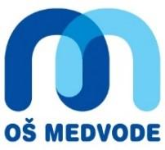
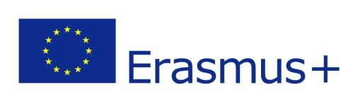
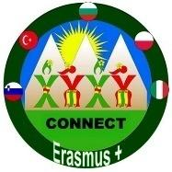
KA229
DISSEMINATION OF ERASMUS+, KA229, "Connect" - SLOVENIA

We disseminated the Erasmus+, Connect via different media:
- school web site:
Erasmus+ KA229 in OŠ Medvode
http://www.os-medvode.si/default.aspx?section=erasmus
Osnovna šola Medvode
http://www.os-medvode.si (novice, projekti: Erasmus+)

- articles in local and regional newspapers (Sotočje)

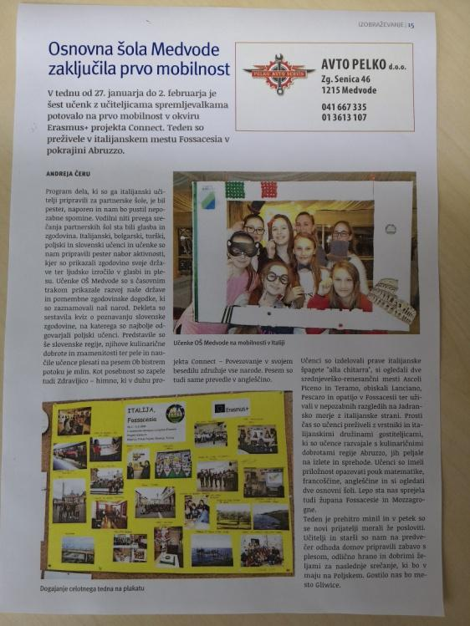
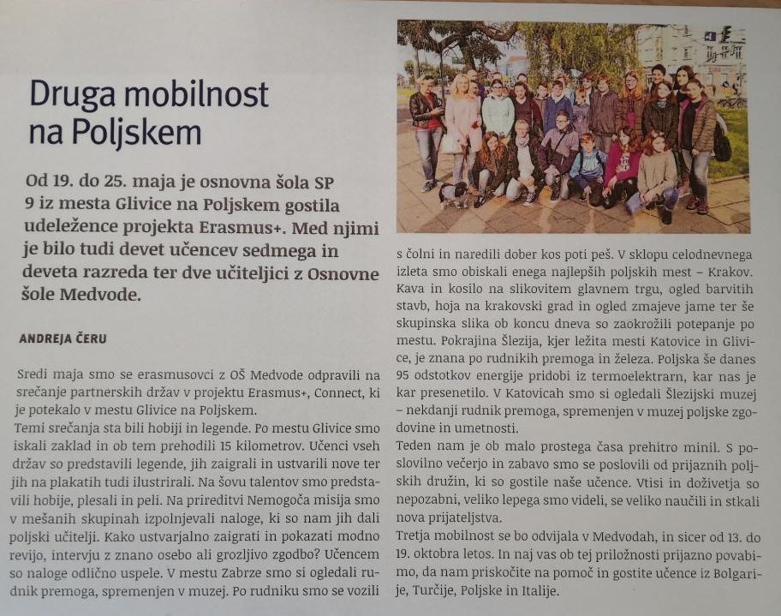
Erasmus+ KA229 project in OŠ Medvode

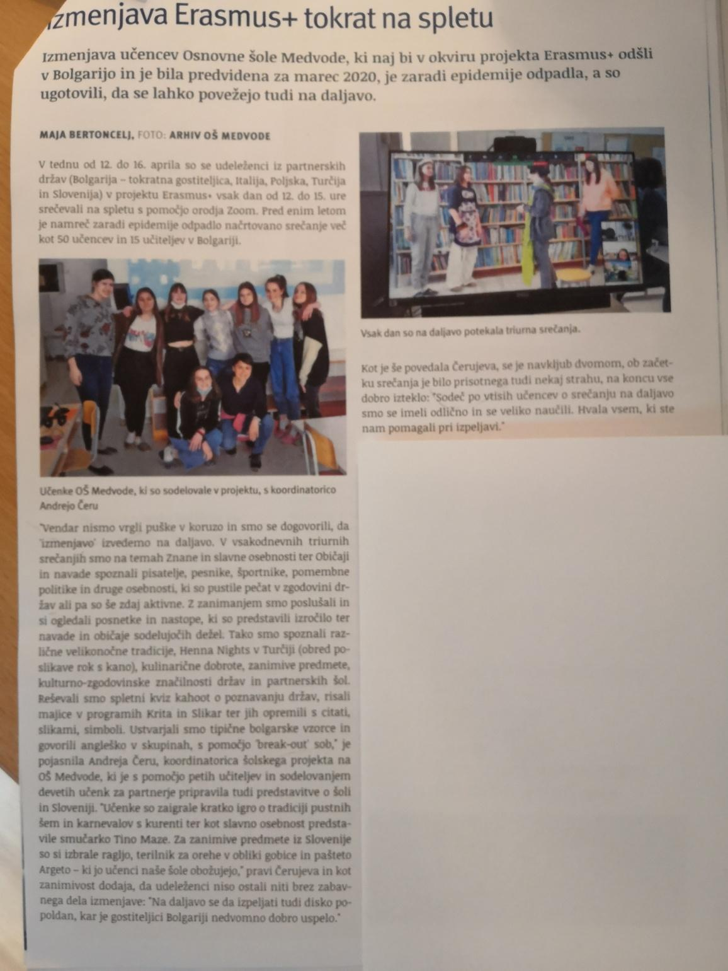

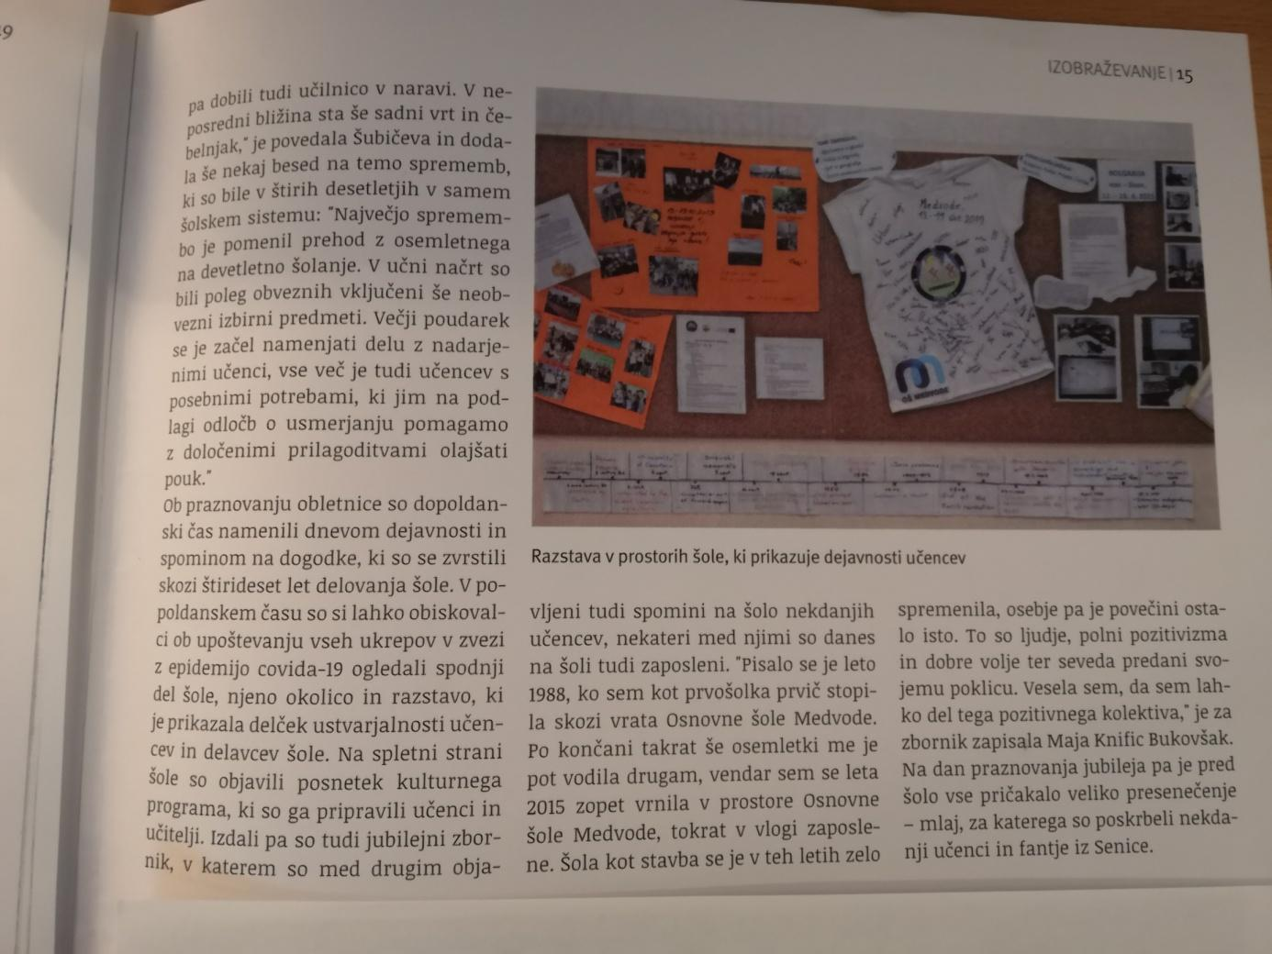

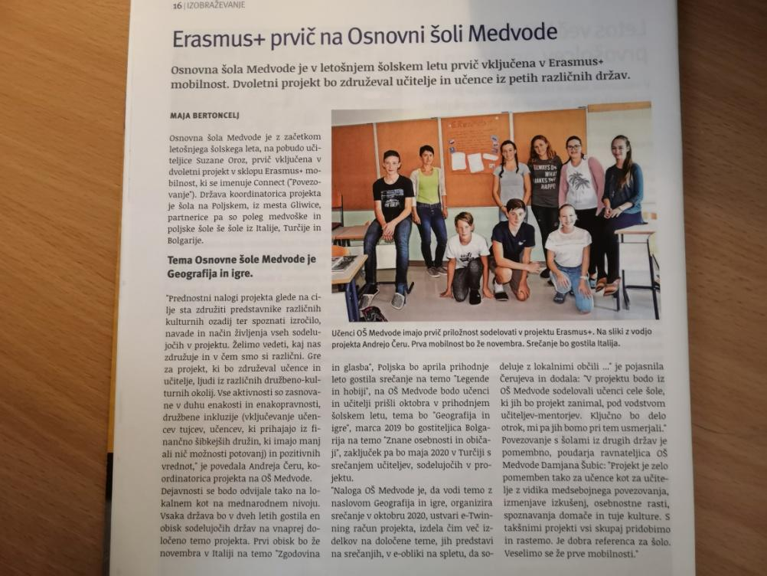

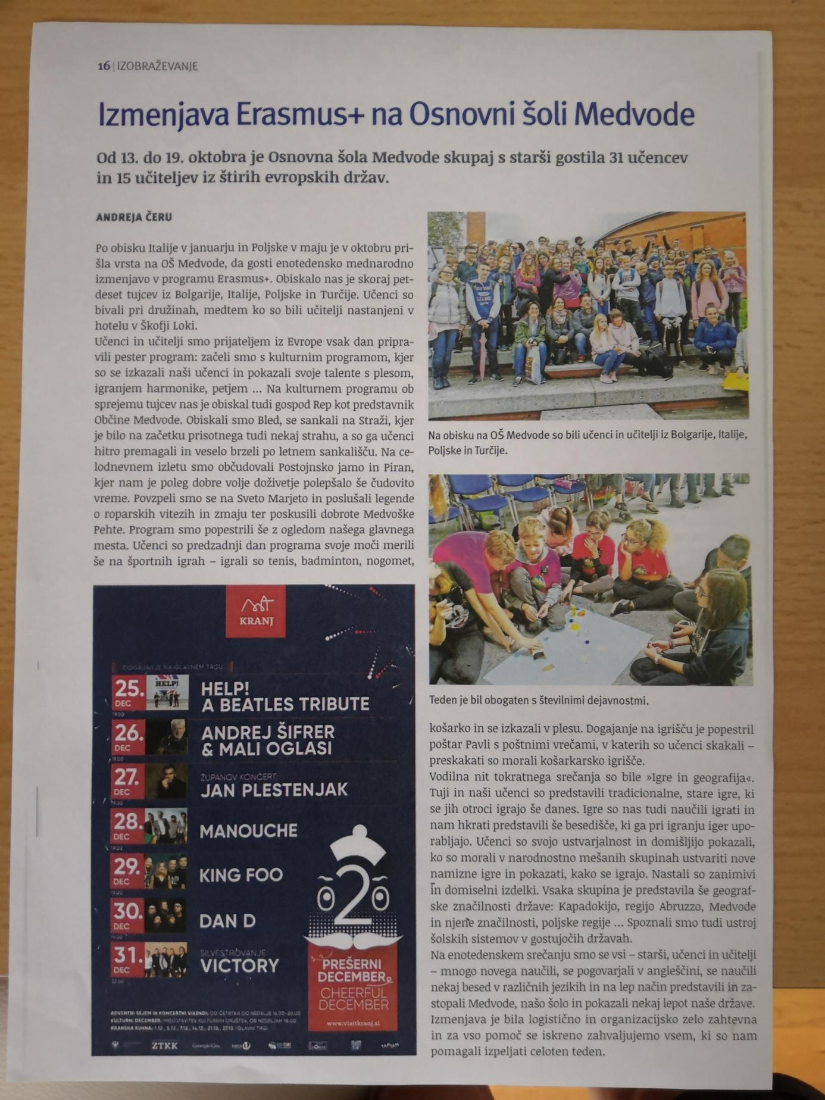

- via parents - teachers meetings
- via meetings of school board (ppt, discussions, minute)
- students who took part in mobility presented the project to their schoolmates in classrooms (ppt, wb site, discussion)
- teachers to teachers meetings
- via FB pages of the project
- exhibitions in school's halls
- via emissions of the school's radio
- via all slovene project "Life long learning" (photos, material on the stand, oral presentation to citizens of Medvode)
- at the occasion of celebrating 40th anniversary of Primary School Medvode we presented the Erasmus+ project in the almanac
Please copy the URL:
https://www.yumpu.com/xx/document/view/65476975/zbornik-40-let-osnovne-sole-medvode

Other project Activities and Events:
- meeting with local authorities, Medvode Tourist Assosiation and Sports Assosiation (Sotočje) for the planning of Slovene mobility in October 2019
- Meeting with School Board in september 2019 - in order to present Erasmus+ and invite families and parents to join and help with the mobility
- Presentation of Erasmus + at “Life long learning week and Medvode Culture Festival (stall, stand, exhibition and oral presentation)

Exhibitions in school's halls: 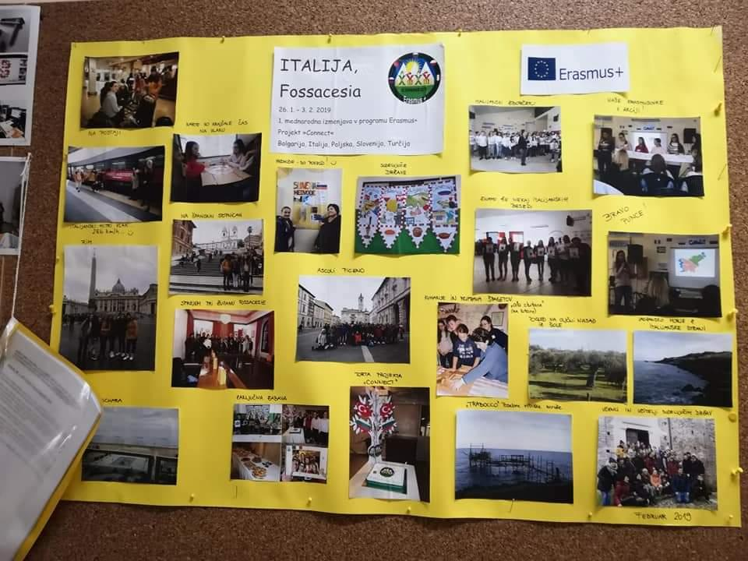

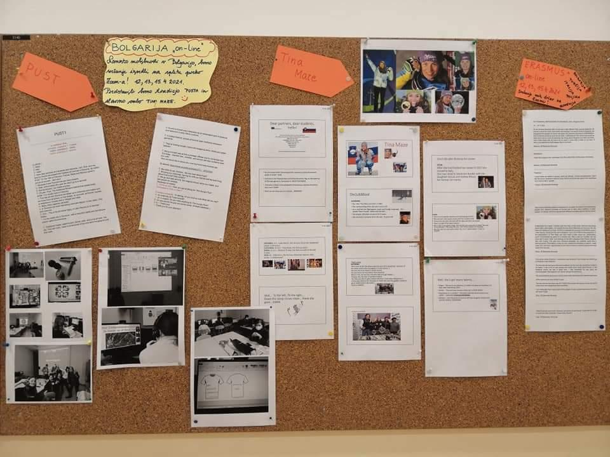
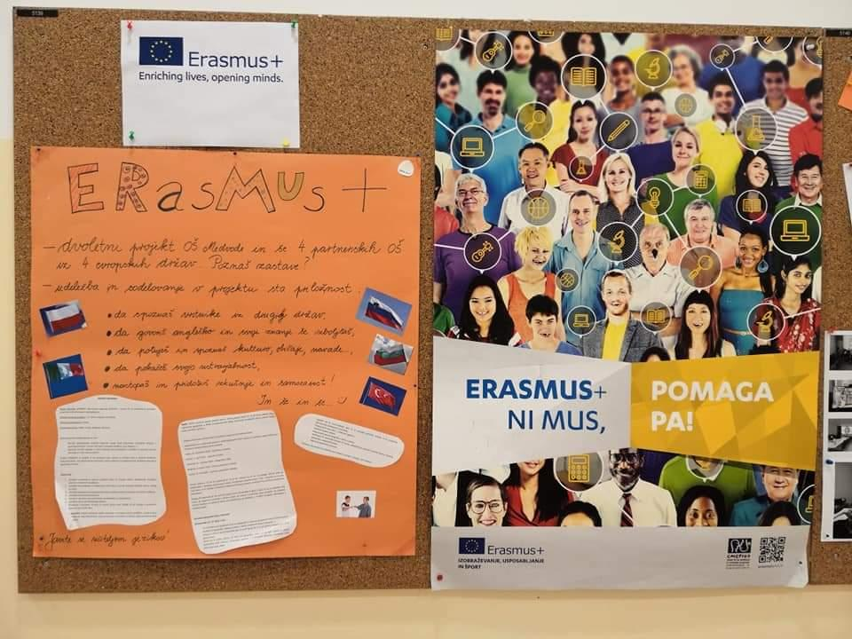
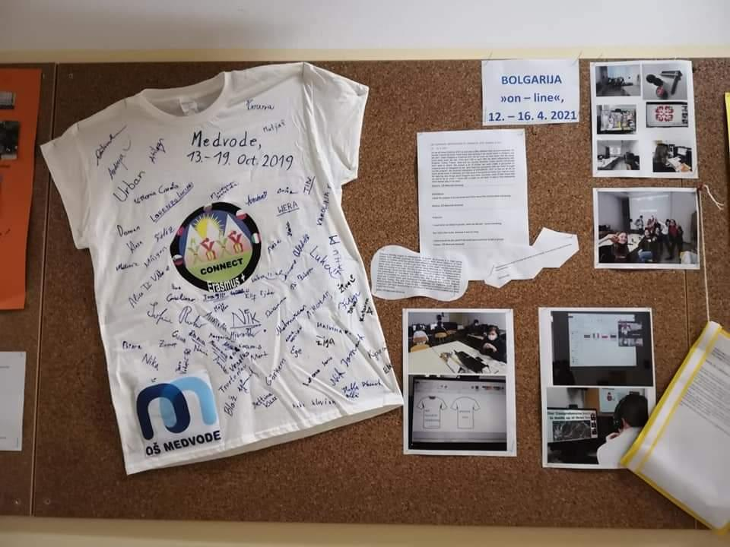
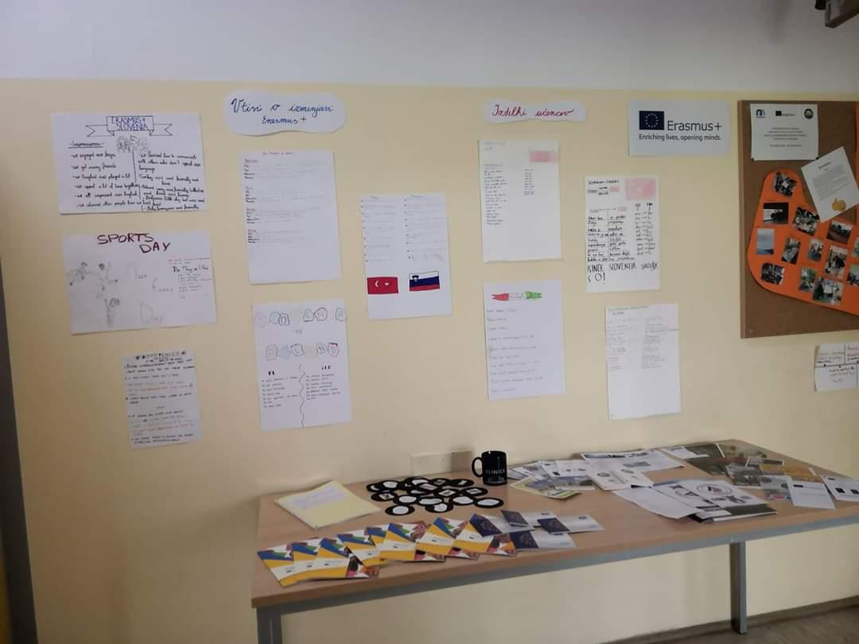

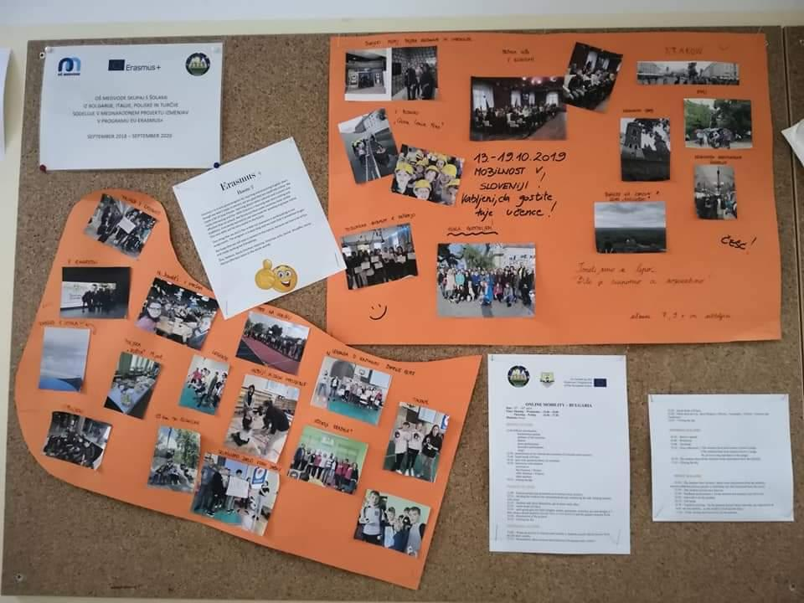

Doc. made by Andreja Čeru

