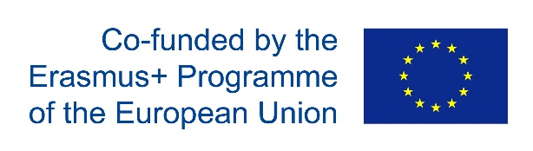

ON LINE CONFERENCE VIA ZOOM

On 25th March 2021 we held an online conference via Zoom.We discussed all the details of the upcoming virtual mobility in Bulgaria.
We reached a decision about the dates ,the hours and the activities , included in the mobility.

