KA229

LESSON PLAN Teachers: Andreja Čeru, Mojca Pintar, students
Subject: Hobbies
Class/age of students: 5 to 9 grade
No. of lessons: 1
Topic: Presenting our hobbies
Objectives:
- students present hobbies to foreign friends, they teach their hobbies to other students
- Nika and Nike show their hobby - dance: jazz ballet, hip hop
- they show basic mooves and students repeat
- then they show their performance
- students of Slovenia present the survey made with 7th graders about their hobbies and and show posters about hobbies
- they improve their english, learn to perform...

Results of the survey:
https://docs.google.com/forms/d/1WbChp-QP5lVrXqC0TficMIUlGQrVs4vzTK69u_7xHL0/edit#responses

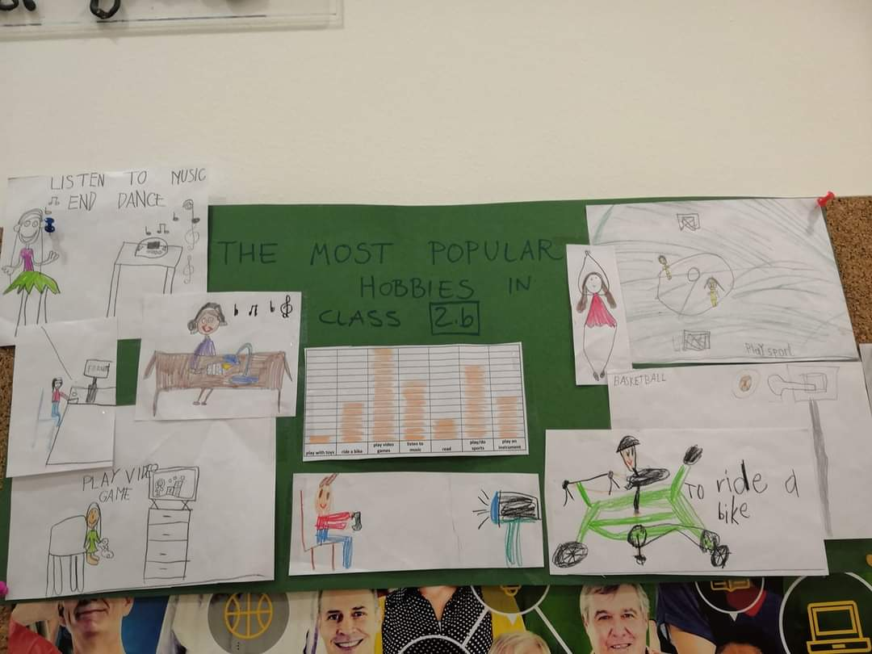
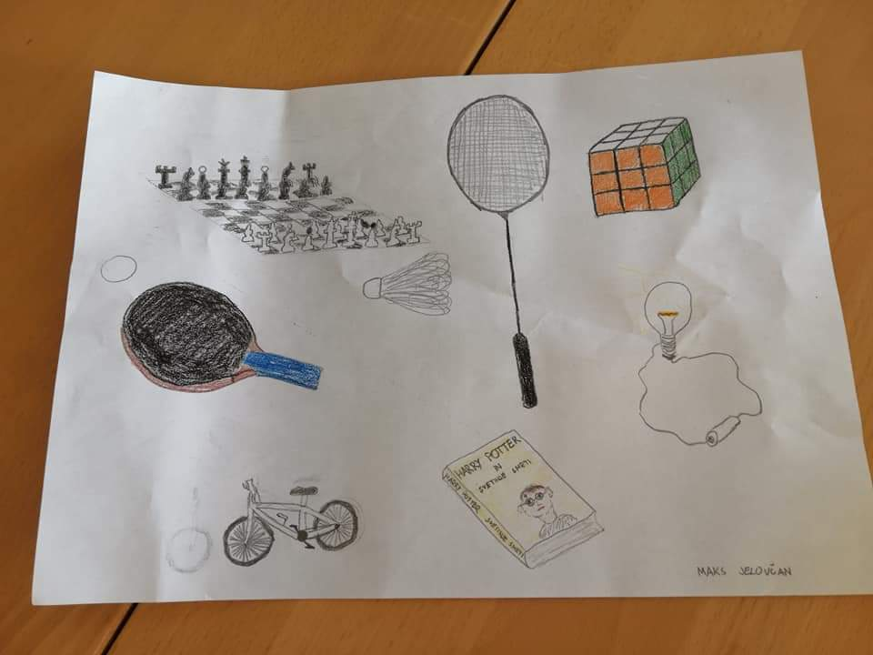

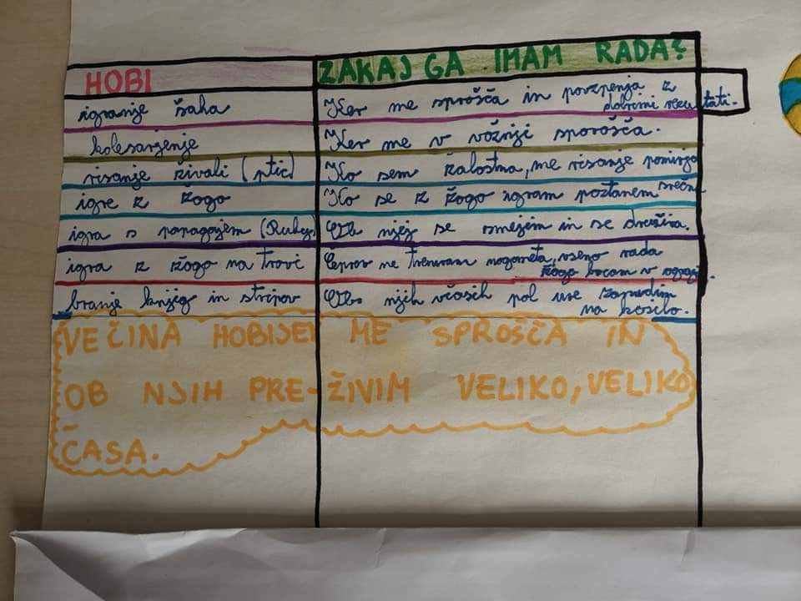

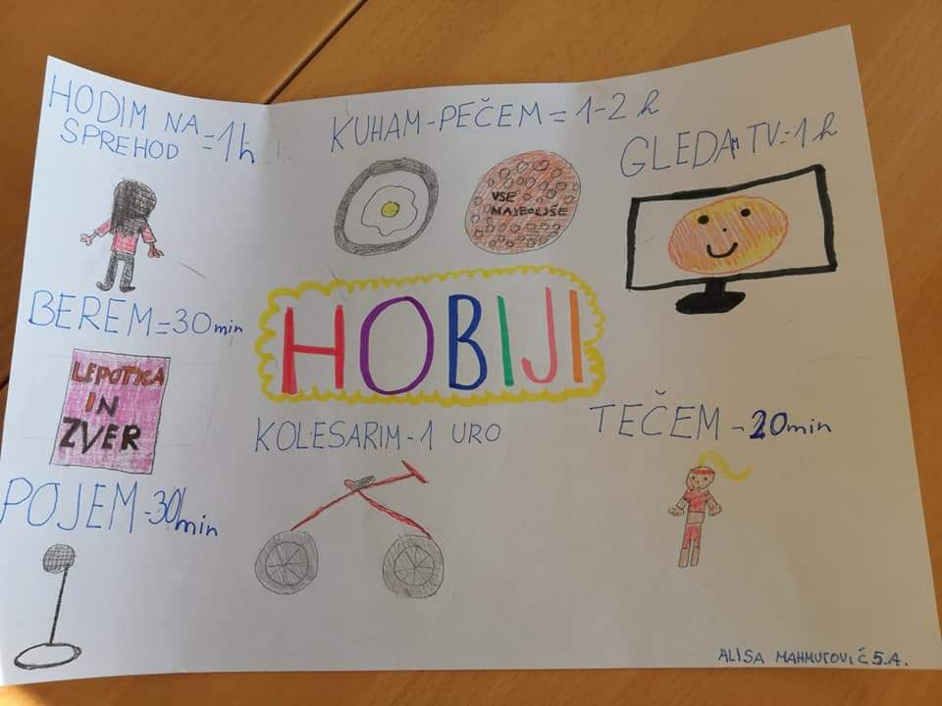
Doc. made by Andreja Čeru

