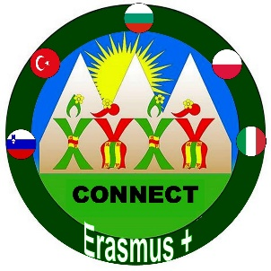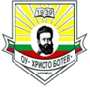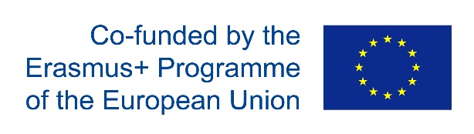

Dissemination – Bulgaria
1.In October 2018 The project has been presented to all the children and teachers in the school. ( ppt presentation )
2.Before each mobility , the schedule was described to the parents.
3.After each mobility , the children involved,described their experiences to the other children and parents.
4.Pictures and text were put on our school webside. https://ou-brenitsa.blogspot.com/p/blog-page_37.html

