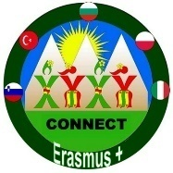
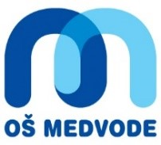
KA229

LESSON PLAN Teachers: Andreja Čeru, Vlasta Sevčnikar, students teaching students
Subject: Slovene language
Class/age of students: 5 to 9 grade
No. of lessons: 1
Topic: Basics of slovene language
Objectives:
- foreign students learn basics of Slovene language, pronounce, speak, correct, read... and foreign students repeat
-learning Slovene language doesn't happen only at work shops of language but also during other activities like sightseeing, staying with families..., during playing games...
- slovene students teach them, show them dictionaries they've made
Games vocabulary: Days of the week: PONEDELJEK, TOREK, SREDA,ČETRTEK, PETEK, SOBOTA, NEDELJA
MAČKA - A CAT monday, tuesday, wednesday...
MIŠ - A MOUSE
IGRATI SE SLEPE MIŠI - TO PLAY BLIND MOUSE (To be blind folded)
Vocabulary of lunch/ food:
KROŽNIK - A PLATE
ŽLICA - A SPOON
VILICA - A FORK
NOŽ - KNIFE
Lahko dobim še .............? - COULD YOU PLEASE GIVE SOME MORE ............?
DOBER TEK - ENJOY YOUR MEAL
Greetings:
DOBER DAN - GOOD MORNING, HELLO LAHKO NOČ - GOOD NIGHT
NASVIDENJE - GOOD BYE
ŽIVIJO - HELLO DOBER VEČER - GOOD EVENING
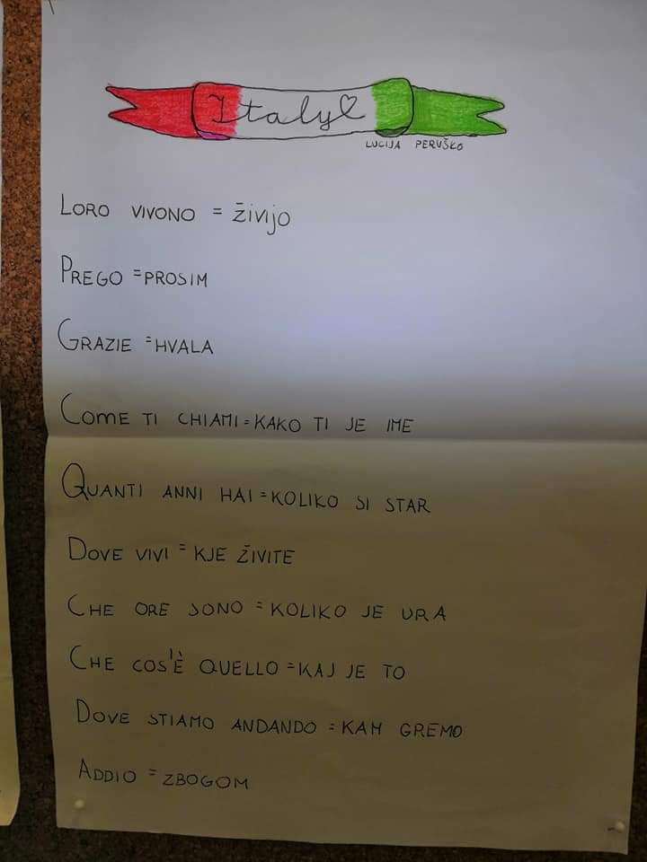
Vocabulary in different languages made by talented kids:

