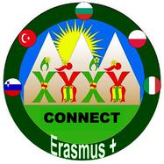
GOOD PRACTISES
-Teb Ataşehir Secondary School has a School TV .
-There is a community in Ataşehir consisted of about 250 teachers.We do folk dances and prepare a show at the end of each year.The teachers in our school started this Project.Its name is ATAFOLK.
-We have sister schools both in İstanbul and in different parts of Turkey.We meet and share our practices with them.Our school also support these schools financially.
-There is a Teacher’s Music Group.
-The teachers meet and have volleyball matches on Saturdays.
-On Sundays,there are trekking trips with teachers,students and parents.
-At the end of each term,there are school picnics.
-At end of each year,there is a family dinner meeting at the school garden with families,students and teachers.There is usually live music.
-There are school trips to Cappodocia,Antalya,Ephesus,Ankara,Mardin and also to Topkapı,Dolmabahçe.

